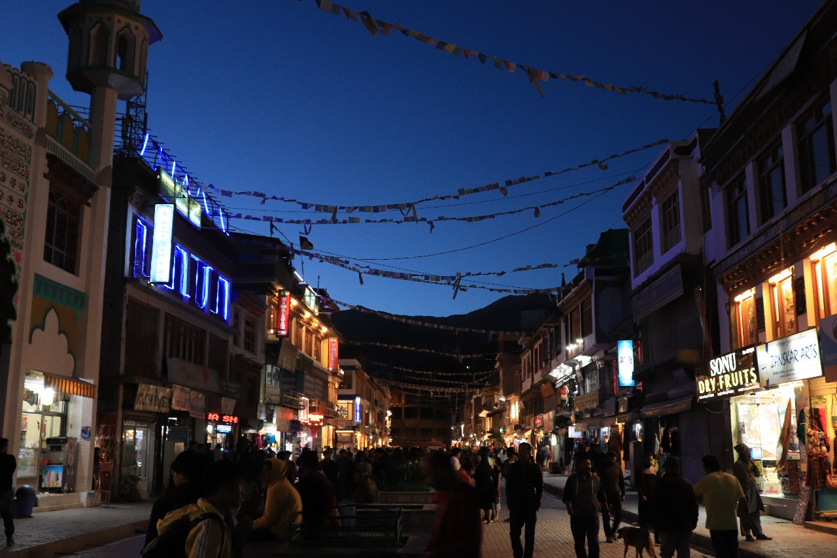
A Peaceful Chaos

We reached our hotel around 6-7 PM in the evening. The moment we arrived, we were advised to rest. The climate, the oxygen levels—everything was new to us. We had heard stories of overexcited travelers who exhausted themselves on the first day, only to spend the rest of the trip sick, vomiting and miserable. So, everyone retreated to their rooms to rest.
But I am not like everyone else. Curiosity runs in my veins. The urge to see everything, to explore every corner, was too strong to ignore. My mind buzzed with questions—what did the market look like? How were the streets at this hour? Unable to resist, I turned to my brother and convinced him to sneak out with me.
We made our way to the market, known as Mall Road. And oh, what a sight it was! It felt like something out of a dream—like pieces of heaven scattered on Earth. The marketplace was like a miniature version of Delhi, but bathed in warm, colorful lights. The vibrant colors blended with the deep darkness of the hills in the background, where the moonlight softly rested on the peaks. It was magical. The place, the people, the hum of conversations—it was a paradox, a quiet place filled with so much energy.
Tourists were busy bargaining, collecting souvenirs—pieces of this place to carry back home. My brother was lost in his own shopping, but I had other plans. I found myself drawn to the locals, eager to hear their stories. I listened to their experiences, their lives in these hills, and the hidden gems of this place that tourists often overlooked. As they spoke, I made notes, listing all the must-visit spots—places untouched by crowds, where the real essence of their culture thrived.
When it was time to leave, I bid them farewell, promising to return the next day with pictures of the places they had told me about. As I walked back, I realized something—this place was a paradox, a perfect blend of peace and chaos. And in that moment, I was completely, blissfully lost in it.

